**Final Project Report Template**

Version 1.1   
Release Date: October 5, 2022

The purpose of the final project report is to share the key takeaways from your completed project–-including the project approach and results–-with policymakers, technology developers, researchers, and the public, among others. Project reports also serve to demonstrate the value of public investment in research and technology development.

**Report Checklist**

Please complete the following report checklist by checking off the box next to each item.

☒ Composed report, including appendices, in this Final Project Report Template.

*To ensure proper formatting, the CEC advises drafting in this template.*

☒ Length of report main body (Introduction through Conclusion) is **10,000 words or fewer**.

☒ Length of appendices is **15 pages or fewer**.

*Note: For reports that are the primary product of the project and for certain other projects, it may be appropriate to produce a longer report. Please request approval of the Commission Agreement Manager (CAM) to exceed the length limitations above*.

☒ Completed all report sections in the following order:

☒ Webpage Abstract

☒ Title Page

☒ Table of Contents (optional for reports with fewer than 10,000 words)

☒ List of Figures (optional for reports with fewer than 10,000 words)

☒ List of Tables (optional for reports with fewer than 10,000 words)

☒ Executive Summary

☒ Introduction

☒ Project Approach

☐ Results

☒ Conclusion

☒ Acknowledgments

☒ References

☒ List of Project Deliverables

☒ Appendices (if included)

☒ Checked that text is organized, clear, and understandable to broad audiences, with consistent and accessible technical terminology.

☒ Formatted report, including appendices, is in accordance with the Writing Style and Formatting Guidance section at the end of this template. <https://www.energy.ca.gov/publications/2020/style-manual-fourth-edition-used-california-energy-commission-staff-lead>

☒ Checked report, including appendices, meets American Disability Act (ADA) compliance as outlined in the Accessibility Guidelines section at the end of this template.

☒ Completed spell-check.

☐ Report has been submitted to ERDDpubs@energy.ca.gov with the agreement number (example: EPC-xx-xxx) entered in the subject line and the Commission Agreement Manager cc’d.

**Webpage Abstract**

GridLAB-D is a research simulator developed by the US Department of Energy and used to study future electricity distribution systems. HiPAS GridLAB-D is a commercial-grade high-performance version of this software developed for four California use-cases: load electrification, distributed resource integration hosting capacity, tariff design, and distribution system resilience. These use-cases address California’s climate change goals, including electricity infrastructure decarbonization and response to climate change impacts on electricity distribution system infrastructure.

HiPAS GridLAB-D is as an open-source product available free-of-charge for users, and easily installed on the most widely used computing platforms. Software support and maintenance infrastructure is open to contributors and administered by professional software engineers in consultation with experienced electrical and mechanical engineers.

Key results:

* Achievement of 97.5% success rate in automatic conversion from Cyme models.
* Simulation speed tests approximately 180 times faster than the DOE version.
* Significant reductions in cloud operating costs, including 94% reduction in storage, and more than 99% reductions in runtime and computing costs.

Linux Foundation Energy, an open-source foundation focused on the power systems sector, adopted HiPAS GridLAB-D and hosts it within the Linux Foundation’s neutral, collaborative community to build the shared digital investments that are transforming the world's relationship to energy.

**FINAL PROJECT REPORT**

**HiPAS GridLAB-D: High Performance Agent-based Simulation with GridLAB-D**

**Agreement Number**: EPC-17-046

**Author(s)**:

David P. Chassin, Alyona I. Teyber, Elizabeth Buechler, Duncan Ragsdale (SLAC National Accelerator Laboratory)

Matthew Tisdale (Gridworks)

**California Energy Commission Project Manager:**

Allen Le

Energy Research and Development Division

**Month Year | CEC-500-XXXX-XXX**

**DISCLAIMER**

**This report was prepared as the result of work sponsored by the California Energy Commission. It does not necessarily represent the views of the Energy Commission, its employees or the State of California. The Energy Commission, the State of California, its employees, contractors, and subcontractors make no warranty, express or implied, and assume no legal liability for the information in this report; nor does any party represent that the uses of this information will not infringe upon privately owned rights. This report has not been approved or disapproved by the California Energy Commission nor has the California Energy Commission passed upon the accuracy or adequacy of the information in this report**

# Table of Contents

Table of Contents 1

List of Figures 2

List of Tables 2

Executive Summary 1

Background 1

Project Purpose and Approach 2

Key Results 3

Knowledge Transfer and Next Steps 4

Introduction 6

GridLAB-D History 6

HiPAS Objectives 6

OpenFIDO 7

GLOW 7

Project Approach 8

Hosting Capacity Analysis 8

Grid Resilience Analysis 8

Electrification 10

Tariff Analysis 10

Open-Source Dissemination 12

Code, Data, and Image Delivery 15

Testing and Validation 17

Training and Education 17

Results 18

Learning-Accelerated Powerflow Solver Performance Results 18

CYME Converter Performance Results 19

Resilience analysis 23

Wildfire mitigation and de-energization protocol 26

Electrification analysis 28

Tariff analysis 30

User surveys 30

Conclusion 33

Lessons Learned 33

Recommendations 34

Acknowledgements 35

References 36

Project Deliverables 37

Appendix A: GitHub Repositories and AWS Resources 1

Appendix B: HiPAS GridLAB-D Subcommands 1

Appendix C: HiPAS GridLAB-D Tools 1

Appendix D: HiPAS GridLAB-D Geodata Packages 1

## List of Figures

Figure 1: Virtual islanding capability for GRIP’s absorption algorithm 10

Figure 2: Tradeoff between computational speed and accuracy 18

Figure 3: Load model performance comparison 20

Figure 4: HiPAS GridLAB-D Load Modeling Runtime 20

Figure 5: Hosting Capacity Analysis Runtime 21

Figure 6: Shear force curve along the pole height 23

Figure 7: Bending moment curve along the pole height 23

Figure 8: Pole stress curve along the pole height 24

Figure 9:Example pole data for pole vulnerability analysis 26

Figure 10:Example pole analysis results for a 230kV power line 26

Figure 11: Wildfire mitigation and de-energization protocol example 27

Figure 12: Graphical output of electrification results for IEEE-13 bus model 29

Figure 13: Graphical output of electrification results for PG&E D0001 model 29

Figure 14: Graphical output of electrification results for PG&E D0001 model 30

Figure 15: Graphical output of tariff design results for a model with 100 houses 31

## List of Tables

Table 1: Percent reduction in power flow computation time 19

Table 2: DOE and HiPAS GridLAB-D Load Modeling Costs Comparison 22

Table 3: Typical pole data for Southern California wood poles 25

Table 4: IEEE 13-bus electrification results 28

Table 5: PG&E D0001 electrification results 28

Table 6: Taxonomy Feeder R1-12470-3 electrification results 28

Table 7: Electric utility tariffs list for manual validation 30

# Executive Summary

GridLAB-D is a research-grade power system simulator developed by the US Department of Energy and used to study future electricity distribution systems. HiPAS GridLAB-D is a commercial-grade high-performance version of this software developed for four California use-cases: load electrification, distributed resource integration hosting capacity, tariff design, and distribution system resilience. These use-cases address California’s climate change goals, including electricity infrastructure decarbonization and response to climate change impacts on electricity distribution system infrastructure.

HiPAS GridLAB-D is as an open-source product available free-of-charge for users, and easily installed on the most widely used computing platforms. Software support and maintenance infrastructure is open to contributors and administered by professional software engineers in consultation with experienced electrical and mechanical engineers.

Key results:

* Achieved 97.5% success rate in automatic conversion from Cyme models.
* Simulation speed tests approximately 180 times faster than the DOE version.
* Significant reductions in cloud operating costs, including 94% reduction in storage, and more than 99% reductions in runtime and computing costs.

Linux Foundation Energy, an open-source foundation focused on the power systems sector, adopted HiPAS GridLAB-D and hosts it within the Linux Foundation’s neutral, collaborative community to build the shared digital investments that are transforming the world's relationship to energy.

## Background

California Investor-Owned Utilities are the owners and operators of distribution systems serving millions of residential, commercial, industrial, and agricultural customers. By 2016, IOU spending on distribution systems constituted between 32% and 40% of annual revenue. Looking ahead, grid modernization efforts which enhance the sensing and automation capabilities of the distribution system through use of smart grid technologies are projected to accelerate the size of utility investment in the distribution system. Customer adoption of distributed energy resources interconnected into the utility distribution system, climate stressors such as wildfires and extreme weather, and decarbonization of buildings and transportation add significant challenges to distribution planning and operation. Utility and customer actions in response to these challenges underpin the states’ climate policies, including clean energy adoption goals and resource mandates such as the following:

* AB 32, which creates a comprehensive program to reduce greenhouse gas (GHG) emissions in California. GHG reduction strategies include a reduction mandate to 1990 levels by 2020 and a cap-and-trade program.
* AB 2514, which requires the CPUC to determine targets for the procurement of viable, cost-effective energy storage systems by load-serving entities.
* SB 350, the Clean Energy and Pollution Reduction Act, which 1) expands California’s RPS goals and requires retail sellers of electricity and local publicly owned electricity to increase their procurement of eligible renewable energy resources to 40% by the end of 2024, 45% by the end of 2027, and 50% by the end of 2030; 2) requires the Energy Commission to establish annual targets for statewide energy efficiency savings in electricity and natural gas final end uses of retail customers by January 1, 2030; and 3) provides for transformation of the Independent System Operator into a regional organization.
* AB 327, which requires IOUs to identify optimal locations of DER deployment and thereby minimize overall system costs and maximize ratepayer benefit from investment in DER.

These regulations impact all market segments and all electricity consumers. To achieve these mandates and other DER goals, California utilities seek more interoperable and efficient tools to plan and operate the grid. The HiPAS GridLAB-D project has provided the development of a necessary tool to bring the stakeholders together to support the adoption of mandates and regulations through modeling and simulation activities.

## Project Purpose and Approach

GridLAB-D is a modern open-source agent-based power system simulation tool developed by US Department of Energy’s (DOE) Office of Electricity to study modern power systems with high renewables, energy storage and demand response at the distribution level. GridLAB-D has been available to the public since 2008. The DOE version of GridLAB-D is highly versatile and scalable, but it has several important limitations for the use-cases that are common to utilities serving ratepayers in California. Specifically,

1. GridLAB-D is difficult to install and deploy in the diverse operating environments found at utilities in California.
2. GridLAB-D requires data that is often difficult to obtain from public sources or is only available from tools and databases that are proprietary and often difficult to access.
3. There are no standard analysis methodologies implemented in GridLAB-D for the identified use-cases required by California utilities.
4. Regulatory agencies need open-source software to perform analyses to consider distribution and tariff planning questions for renewable integration, energy storage and demand response.
5. GridLAB-D is sometimes too slow and too expensive to run for the kinds of planning studies needed by larger utilities.

This HiPAS project upgraded and augmented the DOE version of GridLAB-D to meet the needs identified by the user community in California. These included the ability to run large-scale simulations and analyses on desktop computers, on-premise servers and private clouds, as well as coordinate a large number of hosted cloud computing assets to complete groups of simulations that explore a range of scenarios and options. These upgrades have been integrated into an open-source production release of GridLAB-D that is freely available to the public.

SLAC National Accelerator Laboratory also focused on upgrading the DOE version of GridLAB-D to achieve commercial readiness for use by utilities, researchers, and vendors of smart-grid and renewable energy integration technology.

Initially two use-cases were identified to help identify key capabilities that were to be enabled by HiPAS GridLAB-D, Integration Capacity Analysis (ICA), and Locational Net Benefits Analysis (LNBA). Both use cases were intended to be implemented according to the CPUC methodologies in use at the time the project was begun.

Early on the Technical Advisory Committee recommended dropping LNBA in favor of three other potential more relevant use-cases, i.e., 1) tariff-design, with a focus on the comparative revenue impacts of existing tariffs with tariffs that address new distributed energy resource such as batteries, electric vehicle chargers, and solar panels; 2) electrification, with a focus on electrification of residential uses such a heating, hot water, cooking, and clothes drying; and 3) resilience, with a focus on pole vulnerability to extreme wind events. National Grid participated in the project with a significant in-kind contribution to evaluate the performance of HiPAS GridLAB-D based on their load forecasting use-case. The US Department of Energy also participated in the project with a significant in-kind contribution to evaluate the impact of extreme weather events on utility distribution system infrastructure.

Most of the work completed was focused on restructuring and reorganizing the source code, supporting automatic data conversion and integration, cloud infrastructure, and documentation to improve usability and ease of support by contributors to the HiPAS infrastructure. A new GitHub organization was created and all the support infrastructure for tracking issues, receiving and validating code and data contributions, and releasing updates was put in place by SLAC with the support of Hitachi, Pacific Northwest National Laboratory, Stanford University, the US Department of Energy, and others who have contributed to the open-source repositories.

HiPAS GridLAB-D has been tested and evaluated at National Grid and Southern California Edison. These tests included models and data used for performance analysis and some of the impacts and benefits identified in this report.

## Key Results

As originally proposed, HiPAS GridLAB-D is a common release of GridLAB-D and is used by the OpenFIDO (EPC-17-047) and GLOW (EPC-17-043) projects. In addition, HiPAS GridLAB-D was used in the CEC project "Powernet with Markets" (EPC-15-047) and was a significant part of several proposals to the CEC, including GFO-19-311 (VIPER-CASE) and GFO-21-302 (CWEST). Finally, HiPAS GridLAB-D is currently being used by the US Department of Energy's Grid Resilience Intelligence Platform (GRIP) project funded by the Grid Modernization Laboratory Consortium (GMLC) and Cybersecurity Energy Security and Emergency Response (CESER).

In 2021 National Grid evaluated HiPAS GridLAB-D as an alternative to the DOE version used for previous annual 15-year load forecast. The evaluation considered simulation speed, accuracy of results, and cost of operations as the primary metrics of performance. The study required the conversion of approximately 2000 feeder models from Cyme, the import of historical weather data, and a mapping of load data to network load busses.  The simulations were run for a 1-year horizon, and the results were extrapolated to 15 years using load growth projections and distributed energy resource adoption rates.

The automatic conversion from Cyme models achieved a 97.5% success rate. The remaining models had issues that required manual intervention to correct modeling errors that do not affect Cyme but did affect GridLAB-D simulations. Accuracy was verified by comparing the 2022 simulation results to 2021 and confirming that most of the feeders in 2022 consumed nearly the same energy or slightly more energy than they did in 2021.

Simulation speed tests comparing HiPAS GridLAB-D to the DOE version showed that the CEC version is approximately 180 times faster. Key performance indicators for hosting capacity on the benchmark taxonomy feeders, show that the time to solution (in minutes) as a function of the network size *n* (in nodes) in 870*n*2-83*n*. The time to solve (in seconds) as a function of the number of DERs modeled *d* is 0.57*d*+2.95. A similar hosting capacity performance test on 476 National Grid feeders shows the time to solution as a function of the number of branches *b* is 1,080*b*^2+180*b*.

Cloud operations costs were also evaluated and compared to the DOE version of GridLAB-D for the National Grid study. The DOE version required 17 TB of storage, whereas the CEC version required 1.1 TB of storage, with most of the reduction resulting from corrections to the Cyme converter, which reduced warning outputs during the simulation. The runtime of the DOE version required 25,592 hours at an estimated cost of $113,000. After optimization of the server and simulation, the runtime of the CEC version required a total of 4.5 hours and cost only $20.25.

## Knowledge Transfer and Next Steps

HiPAS GridLAB-D has been adopted by the Linux Foundation Energy (LFE) as a tool available for broad adoption by industry, academic, and government users of distribution system simulation tools. Major utilities in California and nationally have already included HiPAS GridLAB-D in their portfolio of software tools being evaluated and used for various programs, including load forecasting, hosting capacity analysis, electric-vehicle adoption, and distribution system level renewable and demand response integration studies using transactive energy technologies.

The market for users of HiPAS GridLAB-D goes beyond the three major IOUs. The National Rural Electric Cooperative Association (NRECA) is studying the use of HiPAS GridLAB-D for grid resilience planning.  Several California utilities are among NRECA's roughly 900 member utilities that will benefit from the ability to use HiPAS GridLAB-D as a resilience anticipation planning tool for extreme weather events and climate change response.

SLAC plans to continue research and development of HiPAS GridLAB-D in collaboration with Hitachi America Labs to further enhance the software's capabilities, increase the number of supported use-cases, and further reduce barriers to adoption by industry, academic, and government users. The adoption of HiPAS GridLAB-D will also contribute to world-wide growth of a user-base sufficient to ensure steady funding for ongoing technical support, user and developer training and education, and new capabilities at SLAC and other California entities that provide technical, educational, and climate-action support to California utilities and regulators as they develop policies and strategies to decarbonize the state energy infrastructure, responds to climate change, and improve the resilience of the state's electricity infrastructure.

The Technical Advisory Committee provided invaluable support and assistance in helping broaden the community of potential users by introducing key industry players such as LFE to the innovations and potential applications of HiPAS GridLAB-D.

# Introduction

## GridLAB-D History

GridLAB-D was first prototyped by Pacific Northwest National Laboratory (PNNL) under internal funding in 2003. The first open-source version of GridLAB-D was released by PNNL with funding from the US Department of Energy (DOE) in 2007 to study the impact of emerging "smart grid" technology of electricity distribution systems in North America.

DOE used GridLAB-D to answer questions not easily addressed using industry tools available at the time. These studies demonstrated GridLAB-D’s importance in studying future electric systems. Notable studies included the development of a taxonomy of North American feeder models (Schneider 2008), a national study on conservation voltage reduction (Schneider 2010), a study on integrated volt/var control (Schneider 2012), and a study on costs and benefits of transactive energy in ERCOT (Reeve 2022).

Long term support for GridLAB-D users is a challenge for the US Department of Energy due to limits on direct support for commercial use of GridLAB-D which may be regarded as competing with existing industry products that have similar capabilities. Consequently, DOE support for GridLAB-D has historically been focused on academic and government-funded research projects only when industry products don’t provide needed capabilities, are not open-source and customizable, or are too difficult and costly to use.

## HiPAS Objectives

The purpose of the HiPAS GridLAB-D project was to fund the development of an open-source, commercially sustainable, high-performance version of GridLAB-D. GridLAB-D has been shown to be very useful in the study of electric grids with high penetration of renewable energy resources, energy storage, and demand response at the distribution level.

The DOE version GridLAB-D available since 2008 is highly scalable, but has several important limitations for very large-scale simulation studies. It is sometimes too slow and too costly to run on utility-scale planning studies. Regulatory agencies may also have difficulty using GridLAB-D to perform studies that consider distributional effects and tariff questions in the presence of distributed energy resources, renewables, energy storage, and demand response.

The objective of HiPAS GridLAB-D is to modernize the performance and capabilities of the DOE version of GridLAB-D to meet the needs identified by the potential user community in California.  This includes the ability to fully utilize local computing resources as well as access large-scale cloud computing resources cost-effectively using an open-source release of HiPAS GridLAB-D that is available for use by anyone free of charge.

The primary goals of the HiPAS GridLAB-D project include

* Produce a widely usable and fully functional high-performance version of GridLAB-D.
* Deliver a broad range of high-performance agent-based simulation capabilities; and
* Establish a foundation for long-term user and developer support of high-performance versions of GridLAB-D.

## Related Products

HiPAS GridLAB-D was developed jointly with the Open Frameworks for Integration Data Operations (OpenFIDO), under CEC grant EPC-17-047 and GridLAB-D Open Workspace (GLOW) under grant EPC-17-043.  GLOW is a web-based user interface specifically designed for HiPAS GridLAB-D. GLOW provides a more intuitive and user-friendly environment for developers, researchers, and public agencies. Using GLOW results in lower training costs, higher productivity, and increased availability of advanced grid modeling tools.

OpenFIDO is a data interchange, fusion, and analysis framework that provides information exchange between different power systems tools used by utilities, such as Cyme and GridLAB-D. HiPAS GridLAB-D is designed to integrate with OpenFIDO so users of OpenFIDO can import data into GridLAB-D from various external data sources such as Cyme, weather archives, geographic and demographic data sources, and utility SCADA and AMI data sources. OpenFIDO users can perform analysis using HiPAS GridLAB-D without having to download, install, or run GridLAB-D itself. Finally, OpenFIDO users can export results from GridLAB-D to various formats such as CSV, plots, and text reports.

## Use-Cases

HiPAS GridLAB-D was developed with four main analysis use-cases in mind, hosting capacity, tariff design, electrification, and resilience. These use-cases were identified by the Technical Advisory Committee. In addition, these use-cases provided the basis for additional requirements, which themselves can be considered more general use-cases for HiPAS GridLAB-D, giving rise to the following important new features:

* CYME model conversion and import.
* Historical, real-time, and forecasted weather.
* AMI and SCADA data import.
* Distribution system assets, such as poles and duct banks.
* Geographic data sets such as address resolution, ground elevation, vegetation, service territories, census tracts, geographic distances and powerline paths.
* Subcommands to enable internal data and model modification and maintenance routines.
* Tools to enable external data and model generation and creation capabilities.
* Templates to enable open-source distribution of analysis methodologies.
* Output to plotting modules and cloud-deployed/streaming data repositories.
* Support for cloud-based deployment infrastructure, including Amazon AWS and Docker.
* Support for automated continuous integration and continuous deployment (CI/CA)
* Online documentation for each version deployed.

These features result in important new algorithmic, modeling capabilities, and upgrades that are now a standard part of the GridLAB-D suite of tools distributed in the open-source by the Linux Foundation Energy (LF Energy) under the brand name “Arras Energy”.

# Project Approach

In consultation with the Technical Advisory Committee (TAC), the HiPAS GridLAB-D technical team identified four use-cases and an open-source dissemination model to guide the development, validation, and distribution of the final product.

### Hosting Capacity Analysis

The goal of hosting capacity analysis is to quantify the maximum DER generation, EV charger, and demand response that can deployed at any location in a distribution network without violating distribution system voltage, current, or control limits. This process was also referred to as integration capacity analysis (ICA), particularly when focused only on solar resource integration. ICA is achieved using a system-wide iterative power flow solution that examines all the combinations of loading at every customer meter in a distribution system. Distributed generation and DER resources are varied at customer meter, independently, to verify whether a system violation occurs somewhere within a feeder.

### Grid Resilience Analysis

The resilience use-case was supported by the US Department of Energy's Grid Resilience Intelligence Project (GRIP) project, funded by the Solar Energy Technology Office. The goal of GRIP is to assist distribution utilities in responding to grid events by:

* Anticipating grid events using machine learning and artificial intelligence techniques with diverse data sources.
* Absorbing grid events by employing validated control strategies for distributed energy resources; and
* Reducing recovery time by managing distributed energy resources in the case of limited communications.

GRIP builds on previous efforts to collect massive amounts of data that can be used to fine-tune grid operations, including the VADER project and other Grid Modernization Lab Consortium projects on distributed controls and cyber security.

GRIP included innovative applications of artificial intelligence and machine learning for distribution grid resilience using predictive analytics, image recognition, increased “learning” and “problem solving” capabilities for anticipation of grid events. The GRIP project demonstrates distributed control theory with and without communications to absorb and recover from grid events.

GRIP was deployed, tested and validated with utility partners in North America. Anticipation analytics were tested and validated with Southern California Edison; absorption algorithms were tested in Vermont; and extremum seeking controls developed by Lawrence Berkeley National Laboratory were tested with member utilities of the National Rural Electric Cooperative Association.

To effectively absorb and recover from grid events a grid resilience model was developed in HiPAS GridLAB-D, which is coupled with resilience control strategies. HiPAS GridLAB-D code includes a physical failure model for distribution power poles. Using the physical characteristics of poles, such as material type, pole size, pole-top equipment specifications and pole design factors, as well as pole aging information such as age, treatment, maintenance, and general climate conditions, in conjunction with regional weather data, HiPAS GridLAB-D simulates the conditions at which a particular pole may fail.

Along with the physical stress and failure model, a degradation model addresses aging of the poles. An electrical pole is considered at the end of service life by the electrical utility company when the minimum shell thickness is less than 2 inches. Based on this assumption, the degradation model uses the difference between the inside and the outside pole’s core moment at the base of the structure where it is considered weakest. Note that the lifetime of the pole depends on the geographical location, pole treatment, and the weight of the pole-top equipment, all of which are described by the pole data and configuration.

Applying the HiPAS GridLAB-D pole model to GRIP resilience studies allows the simulation to consider the weather vulnerability of the electrical grid based on the electrical network models. Utility-provided Cyme networks and distribution management system (DMS) control models are used as test cases to provide realistic network conditions. The implementation of the electrical feeders starts at substation level and capture components such as transformers, switches, capacitors, electrical lines and metered loads in the model. These models are load-driven and data-driven using real-world information from AMI and SCADA systems.

The absorption component of GRIP includes strategies that allow the network to be broken down into virtual island components using GridLAB-D network modeling capabilities in the efforts to protect and restore the system, after being exposed to a vulnerability. HiPAS GridLAB-D allows users to model the conditions when system faults occur and determine recovery tactics using algorithms developed by Packetized Energy. Using this feature, a power system failure is simulated because of an extreme event, such as high wind, which breaks the network into isolated islands. The networks are assumed to be equipped with solar and battery technology to support the generation requirements within a virtual network island as seen in Figure 1, below. The topology employs large switching devices under specific control strategies that disconnects portions of the grid based on the location of the fault or system vulnerability.

**Figure 1. Virtual islanding capability for GRIP’s absorption algorithm developed by Packetized Energy.**

Figure 1 shows the result of the GRIP absorption algorithm developed by Packatized Energy. In the left panel the component of the GRIP tools are shown in the following order: anticipation, absorption, recovery, data, and admin. Absorption is highlighted.  

In the right panel, four views are shown. The upper left view shows the time configuration with the total simulation duration of 24 hours, the start time of October 15, 2020 at 4 am, the stop time and pause time of October 16, 2020 at 4 am. Below these are the input run until time matching the pause time, and run duration of zero, highlighted in red with a warning that run time must be 15 minutes or greater.  

The upper right view shows a graph of generation, flexible low, storage, and unserved energy. The graph show a varying amount of flexible load and storage, with a surge of generation during an event from around 4 am to around 3 pm. The unserved energy is always zero.

The lower left panel shows a list of simulation components called assets including climate, collector, islanding control, line configuration, line spacing, multi-recorders, overhead line conductors, recorders, super nodes, switches, switch coordinators, and transformer configurations.

The lower right view shows the network topology, with a swing bus connected to three distribution system branches, each with a solar generator, a battery, and loads.  Each system branches is separated from the others using switches.

### Electrification

Electrification analysis examines the impact of converting customer end-uses provided by natural gas, heating oil, or other fossil-energy sources to electricity. In residential buildings, the end-uses that may be converted include heating, cooking, water-heating, and clothes drying. The simulation delivers feeder-level load shapes as the fraction of converted end-uses is increased. In addition, the residential building model identifies when the capacity of the distribution panel in the home is exceeded, and a panel upgrade is required.

### Tariff Analysis

The tariff analysis use-case is designed to include a few tariff structures that IOUs, POUs and CCAs implement to give HiPAS GridLAB-D users the ability to explore a variety of tariff designs for their distribution networks and customer compositions. Tariff models are obtained from the National Renewable Energy Laboratory (NREL) OpenEI database of tariffs. These include recent tariff data for the following utilities.

* **Investor-Owned Utilities**
  + Bear Valley Electric Service
  + Pacific Gas and Electric
  + PacifiCorp
  + San Diego Gas and Electric
  + Southern California Edison (SCE)
* **Publicly Owned LSEs Including Publicly Owned Utilities (POUs)**
  + Alameda Municipal Power
  + City of Anaheim
  + Azusa Light and Water
  + City of Banning
  + Biggs Municipal Utilities
  + Burbank Water and Power
  + CCSF (also called the Power Enterprise of the San Francisco Public Utilities Commission)
  + City of Cerritos, Cerritos Electric Utility
  + City of Industry
  + Colton Public Utilities
  + City of Corona
  + Eastside Power Authority
  + Glendale Water and Power
  + Gridley Electric Utility
  + City of Healdsburg
  + Imperial Irrigation District (IID)
  + Kirkwood Meadows Public Utility District
  + Lassen Municipal Utility District
  + Lathrop Irrigation District
  + Lodi Electric Utility
  + City of Lompoc
  + Los Angeles Department of Water & Power (LADWP)
  + Merced Irrigation District (MeID)
  + Modesto Irrigation District (MID)
  + Moreno Valley Utility (MVU)
  + City of Needles (Public Utility Authority)
  + City of Palo Alto
  + Pasadena Water and Power
  + City of Pittsburg, Pittsburg Power Company Island Energy
  + Port of Oakland
  + Port of Stockton
  + Power and Water Resources Pooling Authority (PWRPA)
  + Rancho Cucamonga Municipal Utility
  + Redding Electric Utility
  + City of Riverside
  + Roseville Electric
  + Sacramento Municipal Utility District (SMUD)
  + City of Shasta Lake
  + Shelter Cove Resort Improvement District
  + Silicon Valley Power (SVP)
  + Trinity Public Utilities District (PUD)
  + Truckee Donner Public Utilities District
  + Turlock Irrigation District (TID)
  + City of Ukiah
  + City of Vernon
  + Victorville Municipal Utilities Services
* **Rural Electric Cooperatives**
  + Anza Electric Cooperative, Inc.
  + Plumas-Sierra Rural Electric Cooperative
  + Surprise Valley Electrification Corporation
  + Valley Electric Association, Inc.
* **Community Choice Aggregators**
  + Apple Valley Choice Energy
  + Clean Power SF
  + Clean Power Alliance
  + Desert Community Energy
  + Lancaster Choice Energy
  + Lancaster Power Authority
  + Marin Clean Energy (MCE)
  + Metropolitan Water District of So. Cal. (MWD)
  + Monterey Bay Community Power
  + Peninsula Clean Energy
  + Pico Rivera Innovative Municipal Energy
  + Pilot Power Group, Inc.
  + Pioneer Community Energy
  + Rancho Mirage Energy Authority
  + Redwood Coast Energy Authority
  + San Jacinto Power
  + San Jose Clean Energy
  + Silicon Valley Clean Energy
  + Solana Energy Alliance
  + Clean Power
  + Valley Clean Energy

### Open-Source Dissemination

The HiPAS GridLAB-D technical team restructured the open-source repository to improve the accessibility and usability of the open-source infrastructure for industry and academic users. This includes the following changes to the DOE GridLAB-D source code:

* **Conversion of legacy C code to modern C++** - All "C" language files in the "source" folder were translated to C++ to modernize the compiler used and improve functionality. Major components of the core simulation were recoded as C++ classes.
* **Cloud infrastructure source code** - The "cloud" folder was added to support the creation of automatically deployed cloud infrastructure on AWS.
* **Build, testing, and deployment actions** - The ".github/workflows" folder was added to deploy GitHub "actions" that support automatic build, testing, and deployment of the "master" and "develop" branches of HiPAS GridLAB-D. Contributions are automatically validated before being incorporated into the main code base.
* **Built-in converters to and from GLM format** - The "converters" folder was added to disseminate the automatic file format converters that support importing and exporting data in various formats such as the following:
  + **CSV** - Reads and writes Comma-Separated Value (CSV) files.
  + **JSON** - Reads and writes JavaScript Object Notation (JSON) files.
  + **MDB** - Reads and writes Microsoft DataBase (MDB) files.
  + **TXT** - Reads and writes general text files.
  + **OMD** - Reads and writes NRECA Open Model Data (OMD) files.
  + **KML** - Reads and writes Keyhole Markup Language (KML) files.
  + **PNG** - Reads and writes Portable Network Graphic (PNG) files.

In addition, the automatic file conversion infrastructure support various file semantics, such as the following:

1. **AMI** - Processes Automatic Metering Infrastructure data.
2. **CEUS** - Processes Commercial End-Use Survey data.
3. **RBSA** - Processes Residential Building Stock Assessment data.
4. **Config** - Processes generic GridLAB-D simulation configuration data.
5. **Modify** - Processes generation GridLAB-D object model update data.
6. **DataFrame** - Processes Pandas DataFrame data.
7. **Geodata** - Processes geographic data.
8. **ICA** - Processes Integration Hosting Capacity analysis data.
9. **NOAA** - Processes National Oceanic and Atmospheric Administration weather and climatological data.
10. **Weather** - Processes GridLAB-D weather data.
11. **Onpoint** - Processes Onpoint weather data (subscription service)
12. **SCADA** - Processes Supervisor Control and Data Acquisition (SCADA) data.
13. **Schneider** - Processes Schneider metering data.
14. **Table** - Processes general table data
15. **Library** - Processes GridLAB-D library data.
16. **Object** - Processes GridLAB-D object data
17. **VisualCrossing** - Processes VisualCrossing weather data (subscription service)
18. **Cyme** - Processes Cyme network, equipment, and load model data.
19. **Player** - Processes GridLAB-D player data.
20. **Spida** - Processes SpidaCalc pole, powerline, and equipment data.

Note that not all file formats support every available semantics.

* **Docker image build infrastructure** - The "docker" folder was created to support building and deployment of docker images from the main GitHub repository.
* **Online documentation source code** - The "docs" folder was added to support dissemination of branch-specific documentation using the SLAC DocsBrowser webtool.
* **Geographic data infrastructure** - The "geodata" folder was added to support distribution of HiPAS Geodata Packages. The geodata packages include the following:
  + **Address** - online address resolution API from Nominatem to convert between latitude/longitude and postal addresses.
  + **Census** - geographic census data such as TIGER shape files.
  + **Distance** - distances between geographic locations.
  + **Elevation** - USGS data on ground elevations at geographic locations.
  + **Powerline** - powerline characteristics at geographic locations based on elevation, line geometry, vegetation, and weather data.
  + **Utility** - utility service territory information for geographic locations.
  + **Vegetation** - vegetation data for geographic locations.
  + **Weather** - weather data for geographic locations.
* **Reorganized module source code** - All the modules in the original main tree have been consolidated into a single "module" folder for improved clarity and simplicity.
* **New python linkage source code** - The "python" module was created to contain all the Python language interface code.
* **Reorganized runtime source code** - The "runtime" folder was moved from the core engine source folder to a separate folder for improved clarity and maintainability.
* **Core source code consolidation** - The "source" folder was created to contain all the core engine code.
* **New subcommand source folder** - The "subcommand" folder was created to contain all the newly created GridLAB-D subcommands.
* **New tools folder** - The "tools" folder was created to contain all the newly created GridLAB-D tools.
* **New tutorials folder** - The "tutorials" folder was created to contain all support files the new online tutorials.

### Code, Data, and Image Delivery

The DOE version of GridLAB-D delivered all the source code and supporting data in a single repository. HiPAS GridLAB-D separates these into distinct open-source repositories, docker image libraries, and cloud-based libraries that improve accessibility, support, and quality control.

These include the following public URL, GitHub, and Dockerhub repositories

* **Websites**
  + **code.gridlabd.us** - Delivers a REST API for the raw data from GitHub as required for direct use by applications. The API is used to access files and data stored on GitHub for long-term open-source distribution, version control, and public access. Updates are committed by developers using the main GitHub repository for HiPAS GridLAB-D
  + **docker.gridlabd.us** - Provides user access to docker images of HiPAS GridLAB-D. Docker images ensure high result reproducibility and portability on different host computer operating systems and machine architectures. Updates are deployed by the action workflows on the main HiPAS GridLAB-D repository
  + **geodata.gridlabd.us** - Provides user access to data used by HiPAS GridLAB-D geodata subcommand. Geodata sets include elevation, vegetation, utility, and census data. Geodata is updated manually from scripts managed from the main HiPAS GridLAB-D GitHub repository.
  + **help.gridlabd.us** - Provides access to the online documentation delivered by the HiPAS GridLAB-D repository. Documentation is delivered for multiple projects and branches provided by GitHub.
  + **install.gridlabd.us** - Provides access to the fast multi-platform installers of HiPAS GridLAB-D. Supported platforms include MacOS, Windows, and several major Linux variants. The install tools are updated from the "cloud" folder in the main HiPAS GridLAB-D repository.
  + **issues.gridlabd.us** - Provides user access to the issue reporting and tracking system in GitHub. Issues are added by users and developers, and managed by the administrators of the main GitHub repository for HiPAS GridLAB-D
  + **library.gridlabd.us** - Provides user access to object libraries. Libraries are managed by the "library" subcommand and disseminated from the "gridlabd-library" repository in GitHub.
  + **models.gridlabd.us** - Provides generic models and analyses for users and developers. Models are disseminated from the "gridlabd-models" repository in GitHub.
  + **news.gridlabd.us** - Provides a venue for announcement about HiPAS GridLAB-D. Topics and submissions are managed by the administrators of the HiPAS GridLAB-D repository.
  + **source.gridlabd.us** - Provides the main source code download entrypoint for developers. The source code is managed and disseminated by the administrators of the main HiPAS GridLAB-D repository.
  + **status.gridlabd.us** - Provides information on the status of HiPAS GridLAB-D development and deployment.
  + **template.gridlabd.us** - Provides access to the analysis templates. Templates are managed and disseminated from the "gridlabd-template" GitHub repository.
  + **tutorials.gridlabd.us** - Provides access to online tutorials for users and developers. Tutorial videos and slides are delivered from this AWS S3 bucket. The website is delivered from the main HiPAS GridLAB-D repository "cloud/website" folder.
  + **version.gridlabd.us** - Provides version check information to users and logs HiPAS GridLAB-D version usage.
  + **weather.gridlabd.us** - Provides access to NREL TMY3 weather data using the "weather" subcommand.
  + **www.gridlabd.us** - Provides the main welcome website for HiPAS GridLAB-D users.
* **GitHub Repositories**
  + **hipas/gridlabd** - This repository contains the main HiPAS GridLAB-D source code, modules, converters, geodata packages, subcommand, runtime files, and tools.
  + **hipas/gridlabd-template** - This repository contains the analysis templates for GridLAB-D users.
  + **hipas/gridlabd-docker** - This repository contains the script to build the HiPAS GridLAB-D docker base image.
  + **hipas/gridlabd-models** - This repository contains sample models and analyses for HiPAS GridLAB-D.
  + **hipas/gridlabd-weather** - This repository contains NREL TMY3 weather data.
  + **hipas/gridlabd-library** - This repository contains object libraries for the powerflow module.
  + **hipas/gridlabd-converters** - This repository contains converters used to automatically import and export data in various formats.
  + **hipas/gridlabd-examples** - This repository contains tutorial example models and analysis for HiPAS GridLAB-D.
* **Docker Image Libraries**
  + **hipas/gridlabd** - This image is the main image for HiPAS GridLAB-D is docker.
  + **hipas/gridlabd_base** - This is the base image used to build the main image.

Note that Linux Foundation Energy plans to use the “arras” GitHub organization instead of “hipas”.

### Testing and Validation

HiPAS GridLAB-D uses the DOE GridLAB-D validation testing infrastructure to perform all the required validation tests when building a new version. Improvements have been made to the testing and validation conventions used and several hundred new tests have been introduced to verify and validate the new features in HiPAS GridLAB-D.

Each template has a separate suite of validation tests introduced to verify the functionality of the templates. The validation and testing result for the hosting capacity, resilience, electrification, and tariff analysis templates are described in the “Results” section.

Under its cost-share commitment National Grid supported the HiPAS GridLAB-D by running load forecasting studies for two consecutive years, first using the DOE version of GridLAB-D in 2021, and then using HiPAS GridLAB-D in 2022. The accuracy, runtime, and costs of these runs were then compared to identify the benefits of upgrading to HiPAS GridLAB-D from the DOE version of GridLAB-D. In addition, the US Department of Energy provided cost-share under the Grid Resilience Intelligence Platform by supporting testing of the resilience use-case at Southern California Edison.

### Training and Education

HiPAS GridLAB-D is delivered with a collection of training/education videos, distributed at the URL <https://tutorials.gridlabd.us/>.

# Results

### Learning-Accelerated Powerflow Solver Performance Results

Performance results for the learning-accelerated powerflow solver framework show that there is a clear tradeoff between speed and accuracy of the simulation. However, computation time can be reduced significantly while still maintaining accuracy at a level that is acceptable for a variety of simulation use-cases.

Figure 2 shows an example of the tradeoff between the power flow simulation time and solution accuracy for the IEEE 123 bus network for the simulation scenario with the lowest loading level. The Newton Raphson baseline results, which represent the fastest achievable performance of the standard implementation (one Newton Raphson iteration per timestep), achieve a voltage magnitude error rate of 10-6 p.u. (MAE). This level of accuracy far exceeds the requirements for many practical simulation use-cases, particularly given the amount of uncertainty typically present in power flow simulation inputs, such as load models and network model parameters. For the IEEE 123 bus network, the learning-accelerated powerflow implementation achieves an accuracy of 2x10-2 to 5x10-5 depending on the fraction of timesteps that the data-driven powerflow model is used. Voltage magnitude prediction errors ranging between 10-4 to 5x10-4 are likely acceptable for many simulation use-cases. Over this range the learning-accelerated approach achieves an 87-92% reduction in the power flow computation time over the standard implementation.

**Figure 2: Tradeoff between computational speed and accuracy for the learning-accelerated powerflow framework for the IEEE 123 bus network**

Figure 2 shows two graphs the trade-off between computation speed and accuracy for the learning accelerated power flow solver.  The left graph is labeled a, and shows the mean absolute error voltage magnitude per unit on the horizontal axis versus the power flow simulation time in seconds on the vertical axis. A horizontal line at 70 seconds denotes the baseline performance of the Newton Raphson solver with an accuracy of 2 times 10 to the minus 6 per unit.  The learning accelerated simulation time drop from 70 seconds at an accuracy of 10 to the minus 5 per unit down to about 5 seconds at 5 times 10 to the minus 4 per unit.

The right graph shows the same results with the mean absolute error voltage phase in degrees on the horizontal axis.  The baseline time is 70 seconds at 10 to the minus 4 degrees. The learning accelerated solvers starts at 70 seconds for 5 times 10 to the minus 4 degrees and drops to 5 seconds at 5 times 10 to the minus 2 degrees.

Table 1 shows the reduction in the power flow-related computation time for different prediction error levels for the four different networks with the lowest loading level. For a voltage magnitude prediction error of 5e-4 p.u. (MAE), the learning-accelerated framework can reduce the power flow computation time by at least 80%. Differences in results between networks can be attributed to differences in network size, the R/X ratio of the lines, and other network model characteristics.

**Table 1: Percent reduction in power flow computation time (%) as a function of the voltage magnitude prediction error.**

|  |  |  |  |
| --- | --- | --- | --- |
| **Network** | **Voltage magnitude error threshold (MAE)** | | |
| **1e-4 p.u.** | **2.5e-4 p.u.** | **5e-4 p.u.** |
| IEEE 13 Bus | 28.0% | 82.2% | 84.9% |
| IEEE 123 Bus | 86.6% | 90.0% | 91.7% |
| PNNL Taxonomy Feeder R1-12.47-3 | 90.0% | 90.7% | 90.7% |
| PNNL Taxonomy Feeder R2-12.47-2 | 73.4% | 79.4% | 80.3% |

### CYME Converter Performance Results

Of the 2009 feeder models studied by National Grid, 1980 (98.6%) were successfully converted to GLM without manual intervention. Of remaining feeders, 25 additional feeders were successfully converted after correcting the following recurring issues:

* Nominal voltage of load objects may mismatch load bus
* Capacitors switches/phases/control settings may mismatch
* Regulator bandwidth units/values may be incorrect
* Load magnitudes may exceed reasonable values for phases
* PV generation on feeder may exceed hosting capacity limit
* Triplex lines are not modeled in CYME resulting loss discrepancy
* Loads may not be connected resulting in total kVA discrepancy
* Asset phases may mismatch
* Transformer model errors may result in incorrect secondary voltages

The remaining 4 feeders were not successfully converted and could not be included in the speed and cost tests.

The annual energy use comparison of the 2022 load simulation compared to 2021 is shown in Figure 3.

**Figure 3: Load model performance comparison**

Figure 3 shows two charts with the load model performance for the 2022 load forecast compared to the 2021 load forecast.  The left chart shows a distribution of the number of feeders with various annual energy use in gigawatt hours. The distribution is show in 5 bins, 0 to 10, 10 to 20, 20 to 30 , 30 to 40, and 40 to 50 gigawatt hours per year.  The first bin shows 1000 feeders in 2021 and 900 feeders in 2022. The second bin shows slightly less than 400 feeders in 2021 and slightly more than 400 feeders in 2022. The third bin shows slightly more than 300 feeders in 2021 and slightly less than 300 feeders in 2022. The fourth bins shows slightly less than 200 feeders in 2021, and nearly 200 feeders in 2022.  The fifth bin shows roughly 20 feeders in 2021 and roughly 50 feeders in 2022.

The inset graph shows the distribution of annual energy use change from 2021 to 2022 in gigawatt hours. The peak change is from 0 to 5, with nearly 1200 feeders, 400 feeders from -5 to 0, and 200 feeders from 5 to 10 gigawatt hours per year. The distribution drops off quickly to zero at plus or minus 20.

**Comparison of the 2021 load forecast performed with the DOE GridLAB-D and the 2022 load forecast performed with the HiPAS GridLAB-D. The inset graph shows the total energy deviation histogram.**

The DOE GridLAB-D version was run on 7 AWS Windows servers with 64 processors and 17 TB of storage each. The 2022 study required 114 hours to complete 1201 simulations.

HiPAS GridLAB-D was run on a single AWS c5a.24xlarge 96 vCPU with 192 GB of RAM and 1 TB of storage running Linux. The 2022 study of 1248 feeders were completed in 3.44 hours and the study of 1871 feeders was completed in 4.44 hours. As a result, the HiPAS GridLAB-D system is estimated to be about 180 times faster than the DOE version, with a performance metric of about 0.7 second/MB.week where the size of GLM model in MegaBytes is in the denominator, as shown in Figure 4.

**Figure 4: HiPAS GridLAB-D Load Modeling Runtime**

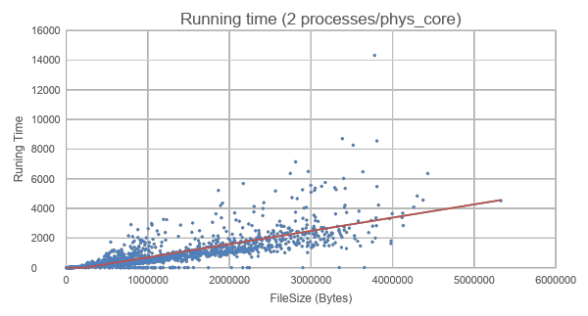

Hosting capacity analysis performance was examined on the PNNL North American Taxonomy Feeders (NATF) and National Grid feeders to evaluate the speed of performance large-scale hosting capacity studies using HiPAS GridLAB-D. For the 25 NATF models, the runtime in minutes as a function of the number of feeder nodes, *n*, is approximated by

*t* = 867 *n*2 - 816 *n* (1)

and the runtime in seconds as a function of the number of DERs, *m*, is approximated by

*t* = 0.57 *m* + 2.95. (2)

The performance as a function of the number of branches, *b*, was evaluated on 476 of the National Grid feeders and is approximated by

*t* = 1.08 *b*2 - 0.18 *b* (3)

in minutes, as shown in Figure 5.

**Figure 5: Hosting Capacity Analysis Runtime**

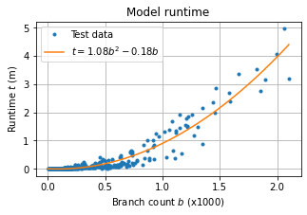

**The hosting capacity analysis runtime approximated based on the number of branches in the feeder.**

Simulation costs were compared for the National Grid load forecasting study based on the cost of running using 2021 DOE GridLAB-D infrastructure and the 2022 HiPAS GridLAB-D infrastructure. The DOE GridLAB-D system required 17 TB of storage and the HiPAS GridLAB-D system required less than 2 TB of storage. A significant fraction of this storage savings came from the elimination of warnings caused by the Cyme to GLM conversion method in the 2021 study, and the resolution or elimination of unneeded warning messages in the GridLAB-D output.

The overall costs are summarized in Table 2. It should be noted that the DOE GridLAB-D version costs were based on the 2021 model as-is. A review of this model revealed significant problems that adversely affected performance, including excessive sub-hourly voltage control action, and a relatively high rate of high load, low voltage solutions which caused excessive Newton-Raphson iterations. These problems were not addressed in the 2021 simulations but were corrected in the 2022 simulation because of the updated Cyme to GLM converter. As a result, these significantly impacted the overall performance and made the speed and costs comparison difficult to assess generally, all other things being equal.

**Table 2: DOE and HiPAS GridLAB-D Load Modeling Costs Comparison**

| **Metric** | **DOE GridLAB-D**  **2021 Load Forecast**  **AWS Windows** | **HiPAS GridLAB-D**  **2022 Load Forecast**  **AWS Linux** |
| --- | --- | --- |
| Runtime (hours) | >25,600 | 4.44 |
| Cost ($) | >113,000 | 20.25 |
| Data size (TB) | ~17 TB | <2 TB |
| Workflow | Sequential | Optimized parallel |

**DOE GridLAB-D running on AWS Windows server compared to HiPAS GridLAB-D running on AWS Linux server. Note that some of the 2021 simulations were not allowed to complete due to excessive runtime and costs, and the total hours and costs of 2021 study do not include the time and costs remaining to complete those simulations.**

### Resilience analysis

Pole vulnerability calculation along the pole determines the pole resisting moment will drop when the pole diameter decreases, thus, the pole may fail at its superstructure. We divide the pole structure on the z-axis into multiple segments and the loading condition for each segment will be analyzed using finite element analysis and considering different forces including self-weight, wind loads, and cable tension. With this effort, HiPAS GridLAB-D and GRIP can conduct similar analysis compared to SPIDAcalc, such as the computation of the worst wind load angle and the critical pole withstand wind speed. Initial example results are depicted in the following figures. However, the team still works on the benchmark and validation of the proposed pole finite element analysis and results will be attached to future project reports.

**Figure 6: Shear force curve along pole height**

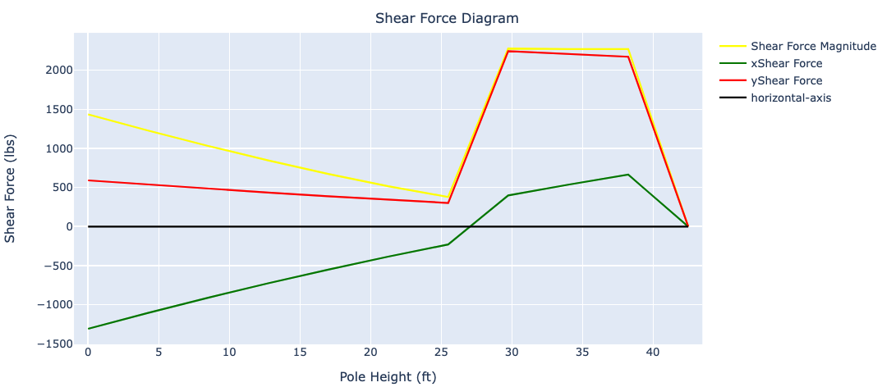

**Figure 7: Bending moment curve along pole height**

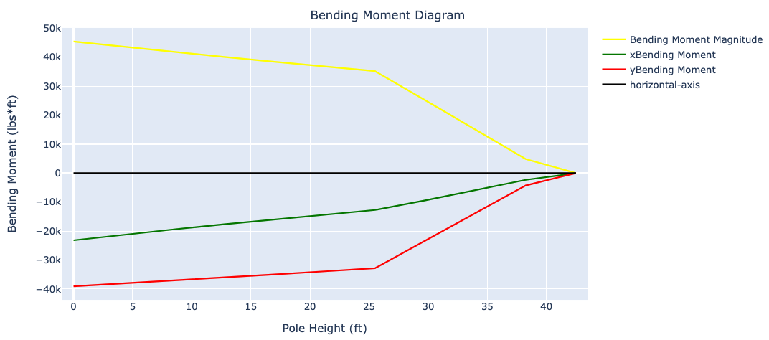

**Figure 8: Pole stress curve along the pole height**

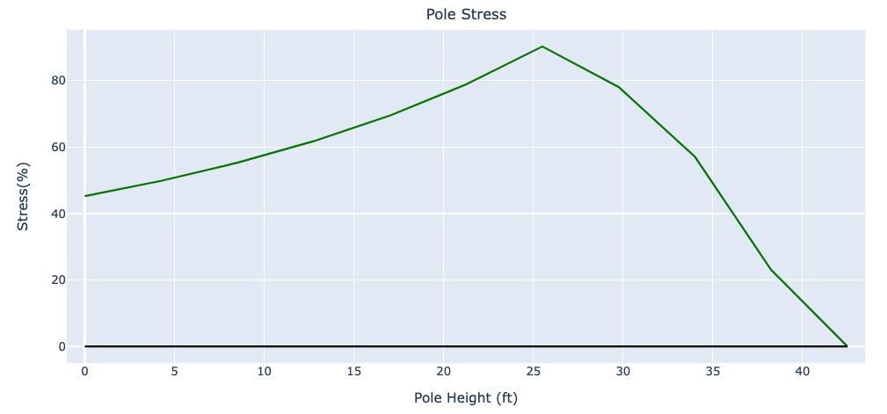

Resilience use-cases was validated for two use-cases:

* Pole analysis
* Vegetation analysis

Pole Analysis

Pole superstructure analysis is implemented in HiPAS. A pole can fail at or near the ground line due to excessive forces on the structure.  The following forces are considered:

1. Pole loading due to pole tilt angle
2. Mounted equipment loading due to pole tilt
3. Wire weight loading due to pole tilt angle
4. Wind pressure on pole
5. Wind loading due to wind pressure on mounted equipment
6. Wire loading due to wind pressure on wire
7. Wire ice loading
8. Loading due to wire tension asymmetry
9. Critical wind speed for pole failure
10. Pole failure probability under wind gust
11. Wire sag loading due to sag asymmetry [Future work]
12. Wire loading due to line sway [Future work]
13. Wire loading due to line gallop [Future work]

The pole resisting moment will drop when the pole diameter decreases, thus, the pole may fail at its superstructure. We divide the pole structure on the z-axis into multiple segments and the loading condition for each segment will be analyzed using finite element analysis and considering different forces including self-weight, wind loads, and cable tension. Initial results are depicted in the following Figure 4 for typical poles installed in California. Figures 4 shows pole analysis on specified 45 ft pole structure. The results were validated using manual calculations for pole loading analysis to ensure accuracy of implementation.

**Table 3: Typical pole data for Southern California wood poles.**

| **Species** | **Length** | **Class** | **AGL** | **GLC** | **Foundation** | **Ground Water Level** | **Lean Angle** | **Lean Direction** | **Capacity Adjustment** | **Effective Allowable Stress** |
| --- | --- | --- | --- | --- | --- | --- | --- | --- | --- | --- |
| Douglas Fir | 40' | 5 | 34' 6" | 31" | None | None | 0 ° | 0 ° | 100% | 8000 lb/in² |
| Douglas Fir | 50' | 4 | 42' 6" | 38 1/4" | None | None | 0 ° | 0 ° | 100% | 8000 lb/in² |
| Douglas Fir | 45' | 4 | 38' 6" | 39" | None | None | 0 ° | 0 ° | 100% | 8000 lb/in² |
| Douglas Fir | 50' | 1 | 41' 6" | 41 1/4" | None | None | 0 ° | 0 ° | 100% | 8000 lb/in² |
| Douglas Fir | 45' | 4 | 37' 4" | 39" | None | None | 0 ° | 0 ° | 100% | 8000 lb/in² |

Vegetation Analysis

Vegetation analysis was tested on historical data of events. Vegetation data was obtained from California Forest Observatory 2020 dataset. The results are generated using a Folium map in HTML format indicating the 230kV PG&E transmission line through Portola Valley, a high risk to wildfire region due to vegetation density and close proximity to communities as seen in Figure 9. Figure 10 illustrates the most recent high wind event on March 21, 2023. Each marker represents a pole, black indicates low vegetation strike risk, while red indicates high vegetation strike risk. The analysis identifies a number of at risk sections. During this event, wind speeds peaked at 11.62 m/s, while the wind gust reached 23.69 m/s as shown in Figure 11. Notably, this event resulted in a multi-day power outage and impacted critical SLAC operations.

Figure 9 and 10 show the mapped results using the HTML output converter for a Folium map.

**Figure 9: Example pole data for pole vulnerability analysis**

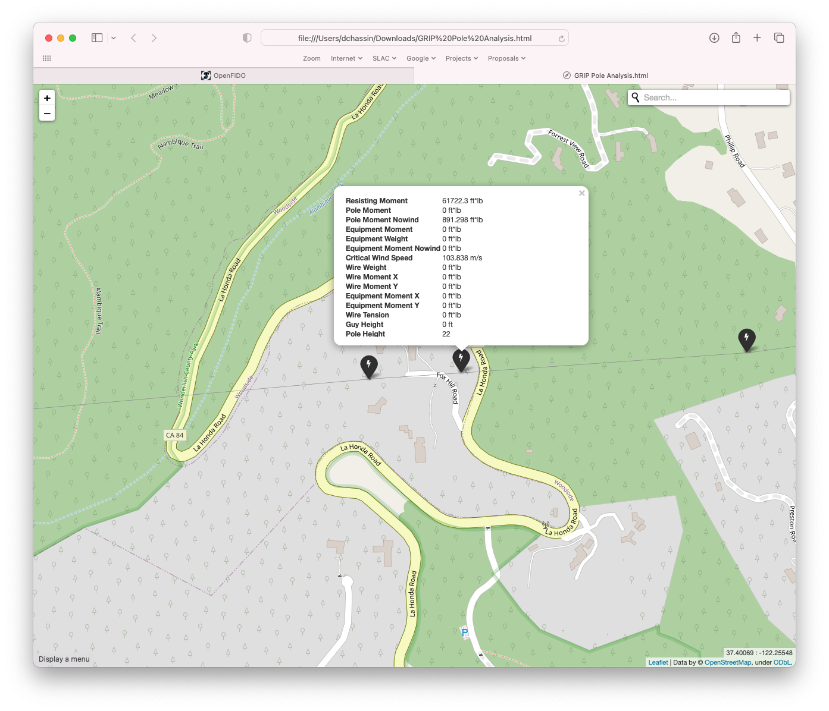

**Figure 10: Example pole analysis results for a 230kV power line showing high-wind impact of grid even in March 2023.**

Figure 10 shows a map of the 230 kilovolt power line from Skyline ridge above Portola Valley California to SLAC National Accelerator Laboratory in Menlo Park California. Tags are indicated at regular intervals where wind-driven vegetation contact with the power line is evaluated. Red tags are shown in some wooded areas where contact is most likely. A star burst is shown where a high wind event on March 21, 2023 occurred causing a tree to fall on the power line cutting service to the Laboratory for several days


### Wildfire mitigation and de-energization protocol

After building a model of the PGE Napa County distribution system, a simulation during the time period of October 15, 2021, to October 21, 2021 was performed. In this time, an actual PSPS event was conducted by PGE which lasted several days and ended when a light rain greatly reduced fire risk. The results are shown in Figures 11(a) - 11(d) indicating how the ignition probability increases over time in response to increases in wind, but the normalized fire potential index decreases over time to account for rain reducing the fire potential. This drastic reduction in fire potential is what causes the number of grid sections turned on to increase, as shown in Figure 11(e).

**Figure 11: Wildfire mitigation and de-energization protocol example**

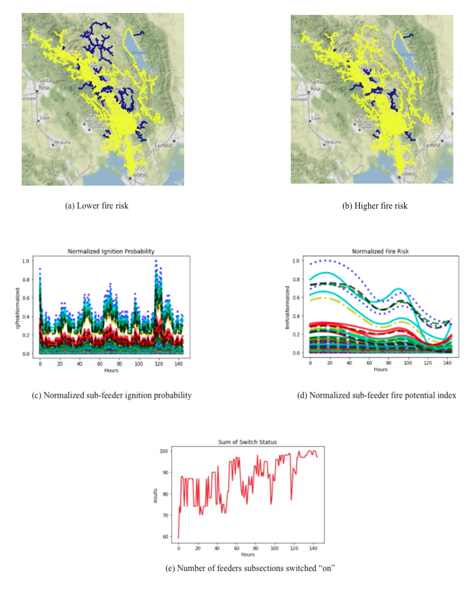

### Electrification analysis

The electrification use-case is validated using the electrification template autotest. The template is tested on three feeder models, the IEEE 13-bus model, the PG&E taxonomy feeder model D0001, and the DOE MGI taxonomy feeder model R1-12470-3. The IEEE 13-bus model is tested with 1 fully electric and 1 fully gas home for the entire year 2020. The D0001 model is tested with the same number of homes for the month of December 2020. The R1-12470-3 test with 20 electric homes and 10 gas homes for the month of January 2020. The baseline results for these models are shown in Tables 4-6.

**Table 4: IEEE 13-bus electrification results**

| **House Type** | **Phases** | **Voltage**  **[V]** | **Energy  [kWh]** | **Peak power  [kW]** |
| --- | --- | --- | --- | --- |
| Electric | AS | 120 | 8,468 | 3.8 |
| Electric | BS | 120 | 8,468 | 4.0 |
| Electric | CS | 120 | 8,468 | 3.9 |
| Gas | AS | 120 | 6,266 | 3.5 |
| Gas | BS | 120 | 6,266 | 3.5 |
| Gas | CS | 120 | 6,266 | 3.5 |

**Table 5: PG&E D0001 electrification results**

| **Timestamp** | **Phases** | **Voltage**  **[V]** | **Energy  [kWh]** | **Peak power  [kW]** |
| --- | --- | --- | --- | --- |
| Electric | AS | 120 | 610 | 3.9 |
| Electric | BS | 120 | 610 | 3.8 |
| Electric | CS | 120 | 610 | 3.8 |
| Gas | AS | 120 | 451 | 3.5 |
| Gas | BS | 120 | 451 | 3.5 |
| Gas | CS | 120 | 451 | 3.5 |

**Table 6: Taxonomy Feeder R1-12470-3 electrification results**

| **Timestamp** | **Phases** | **Voltage**  **[V]** | **Energy  [kWh]** | **Peak power  [kW]** |
| --- | --- | --- | --- | --- |
| Electric | AS | 120 | 12,198 | 76.9 |
| Electric | BS | 120 | 12,198 | 76.9 |
| Electric | CS | 120 | 12,198 | 76.9 |
| Gas | AS | 120 | 4,516 | 35.2 |
| Gas | BS | 120 | 4,516 | 35.2 |
| Gas | CS | 120 | 4,513 | 35.2 |

Figs. 12-14 show the results the IEEE-13 bus, PG&E D0001, and Taxonomy R1-1247-3 model electrification studies, with the peak power (a), and the total energy (b) for an 100% electric (left 3 phases) and 100% gas home (right 3 phases).

**Figure 12: Graphical output of electrification results for IEEE-13 bus model**

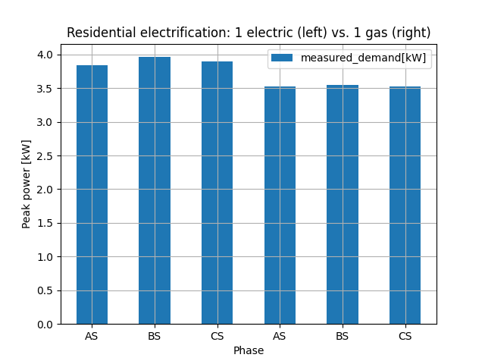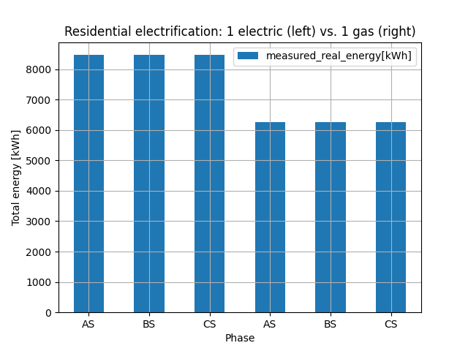

(a) Peak demand (b) Total energy

**Figure 13: Graphical output of electrification results for PG&E D0001 model**

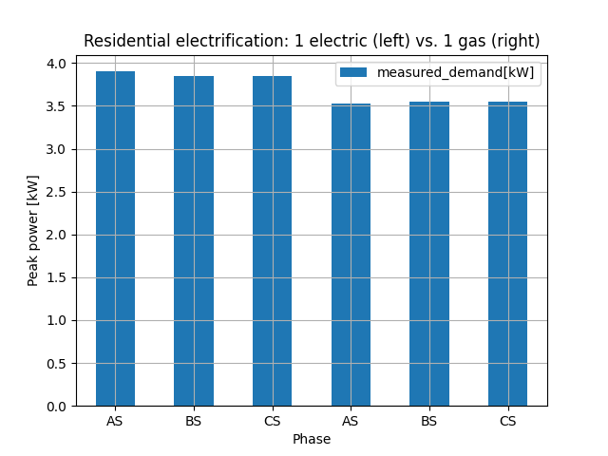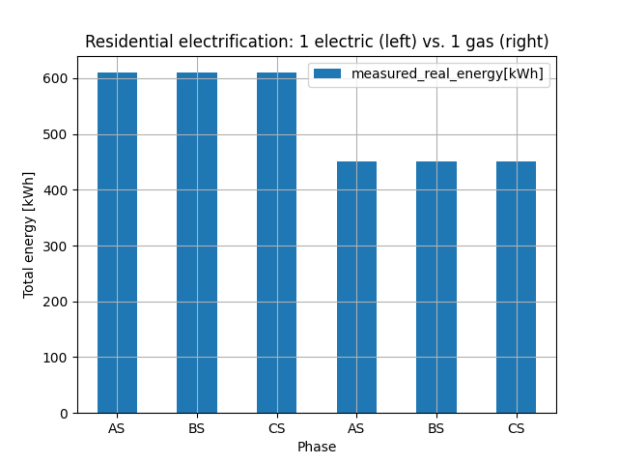

(a) Peak demand (b) Total energy

**Figure 14: Graphical output of electrification results for PG&E D0001 model**

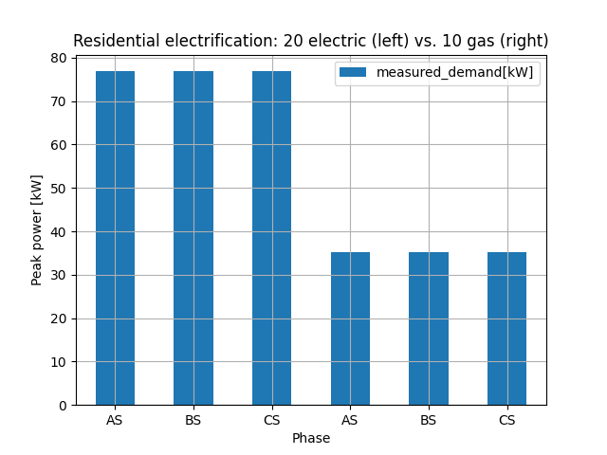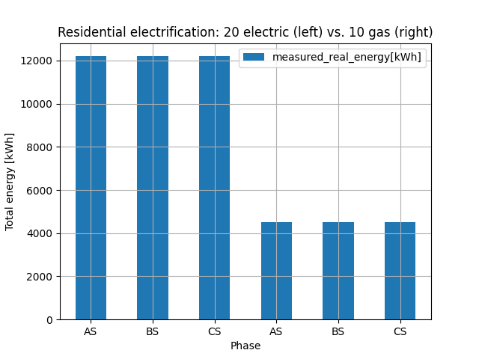

(a) Peak demand (b) Total energy

### Tariff analysis

The testing and validation was a manual calculation method in Excel, for 1 year to confirm the accuracy of the tariff design implementation. The calculation was implemented for 1 house to reduce complexity. HiPAS GridLAB-D provided the power use data, including peak power, energy use and weather correlation for the appropriate region where the tariff is listed for. The tariff design validation was completed for PG&E, SCE, and SDG&E tariffs as listed below:

**Table 7: Electrical utility tariffs list for manual validation.**

| **Utility** | **Sector** | **Name** | **Type** | **Region** | **Inclining Block Rate** |
| --- | --- | --- | --- | --- | --- |
| Pacific Gas & Electric Co | Residential | E-TOU-C3 | TOU | Region R | TRUE |
| Pacific Gas & Electric Co | Residential | E-7 -Residential Time of Use Baseline | TOU | Region P | TRUE |
| Pacific Gas & Electric Co | Residential | E-1 | TOU | Region T | TRUE |
| Pacific Gas & Electric Co | Residential | E-7 | TOU | Region P | TRUE |
| Pacific Gas & Electric Co | Residential | E-6 | TOU | Region Z | TRUE |
| San Diego Gas & Electric Co | Residential | DR | TOU | NaN | TRUE |
| San Diego Gas & Electric Co | Residential | EV-TOU-2 | TOU | NaN | TRUE |
| San Diego Gas & Electric Co | Residential | DR | TOU | Mountain Baseline Region | TRUE |
| Southern California Edison Co | Residential | TOU-D-B | TOU | NaN | TRUE |
| Southern California Edison Co | Residential | TOU-D-TEV | TOU | Region 15 | TRUE |

Performance of tariff design template was completed and results obtained are as follows:

* Verified using manual calculation for PG&E residential tariffs while testing 1 house simulation for a year. Percent error determined: 0%
* Performance verified using Docker environment release `hipas/gridlabd:develop`: 499.10s user 13.97s system 99% cpu 8:34.16 total

Tariff design results are for a scaled analysis to 100 houses is as seen in Figure 15.

**Figure 15: Graphical output of tariff design results for a model with 100 houses**

Figure 15 shows four plots illustrating the output of tariff design analysis for 100 homes. 

Subplot (a) shows the distribution of annual charges ranging from $3,300 to $4,350 with two peaks around $3,600 and $4,000, with 25 and 23 homes, respectively.*Subplot (b) shows the distribution of peak power demand with only two bins around 6.4 kilowatts and 9.0 kilowatts with 20 and 80 homes, respectively.
*

(a) Distribution of Charges (b) Distribution of Peak Power

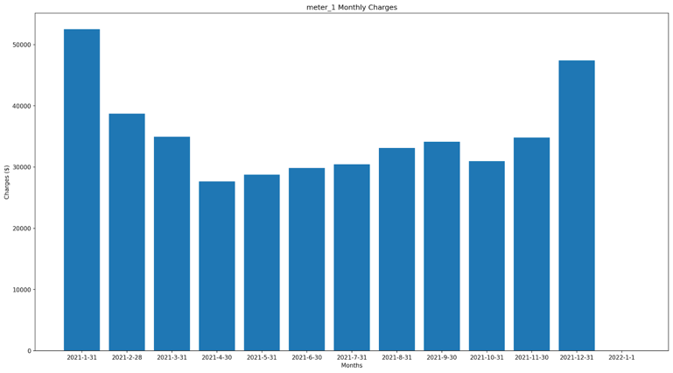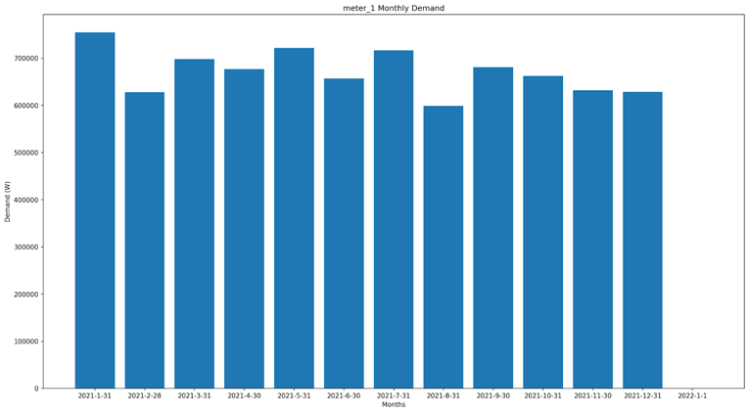

  (c) Monthly Total Revenue (d) Monthly Total Demand

### User surveys

SLAC commissioned survey 21 industry contacts regarding GridLAB-D and received responses from 13 companies.

1. *What's the experience working with the implementation, customization, and support teams? Is the software easily integrated within the daily workflow, and are modifications easy to implement? Can those experienced with distributed power systems easily use and interpret the simulations?*   
     
   Interviewees indicated long-term use of the software and worked with development teams to customize the software or address bugs in the system. In addition, the development team was knowledgeable and enabled engineers to interpret the resultant simulation data.
2. *How accurately does the software model distribute power systems? Does it successfully integrate batteries, wind, solar, hydroelectric, nuclear, and coal-based power systems? Can it integrate next-generation distributed systems within existing non-distributed systems?*  
     
   Users of the software were very satisfied with its capabilities, but it could be easier to customize the software for applications. For example, one user indicated customizing the system to accommodate multiple feeders would be valuable in future iterations of the software.
3. *What changes have been made to existing distributed systems based on the software's analysis? Do these changes improve performance and reliability and decrease cost?*  
     
   One interviewee uses GridLAB-D for hosting capacity analysis, electrification, resilience, and tariff evaluation. The analysis helped reveal measures to improve grid reliability and cost reduction.
4. *Do you believe the software can convince other regions to invest and/or implement distributed systems based on its benefits/analysis?*  
     
   All users believed the software and its subsequent benefits could be used to convince others to improve distributed systems.
5. *How long does it take to perform a simulation? Is current performance a hindrance to wider use and adoption?*  
     
   The users indicated it takes three months to a year to implement and debug the software before simulations can be performed. It would be preferred that in future iterations of the software, the performance and implementation are significantly improved. The interviewees were not impressed with the software's performance.
6. *Would the data required by the simulations be readily available? If not, what are the problems encountered in acquiring the needed data, and how do you address them?*  
     
   Importing data into the GridLAB-D is a significant challenge for the users as it is acquired from other software platforms. In addition, the process is an extreme time burden and should be improved in further software development of GridLAB-D.

It was not always clear in the responses to which version of GridLAB-D the survey respondents were referring. Only two of the twenty-one contacts responded to a follow-up phone conversation. While it is unclear why so few respondents agreed to a follow-up call, it may be due to lack of interest in the software and the burden of deploying new tools in an existing infrastructure (i.e., the technology may be too advanced for current conditions). Both users who did respond noted that the deployment of GridLAB-D is a lengthy process that does not accommodate all scenarios. In addition, importing the required data into GridLAB-D is tiresome and may have limited interest and use of the software with other companies. These challenges may have discouraged them from using the software. Furthermore, the branding may not have fully resonated with the potential cost-effective improvements the software can provide to distributed systems, and it is not clear to which version of GridLAB-D these respondents were referring.

# Conclusion

HiPAS GridLAB-D was successfully developed and deployed as an open-source enhancement to the DOE version of GridLAB-D. As an enhanced version of GridLAB-D, HiPAS California meets its climate change mitigation goals as directed by AB32, AB2514, SB 350, and AB 327. HiPAS GridLAB-D overcomes important limitations for the principal use-cases identified under the project, i.e., hosting capacity analysis, tariff design analysis, electrification analysis, and resilience analysis.

Key capabilities introduced in HiPAS GridLAB-D that provide benefits and value to California utilities and ratepayers include the following.

* HiPAS GridLAB-D is easy to install and deploy in diverse operating environment found at California utilities.
* HiPAS GridLAB-D provides converters, geographic data tools, converters, subcommands, and tools to facilitate reliable and fast access to public sources of data and models needed to run GridLAB-D on the use-cases identified by the project.
* HiPAS GridLAB-D introduces templates for standardized analysis in each use-case identified for the project. The template framework provides a mechanism for utilities and regulators to share common methods for performing the analyses identified for each use-case identified by the project.
* HiPAS GridLAB-D is available as an open-source software that can be used by anyone free of charge on laptop, workstations, on-premise servers, and cloud infrastructure with either custom-builds, pre-built downloadable installations, and docker images.
* HiPAS GridLAB-D provides significant performance enhancements to reduce runtime and run costs, particularly for large analysis tasks required by utilities in California.
* HiPAS GridLAB-D was validated at multiple utilities for the resilience and load forecasting use-case analyses.

After completion of the development and deployment, HiPAS GridLAB-D was transferred successfully to Linux Foundation Energy (LFE). As of December 2022, all the operational resources on GitHub and AWS are under the purview of the LFE Arras project Technical Steering Committee.

## Lessons Learned

The HiPAS GridLAB-D project teams identified the following lessons learning during the conduct of the project. The following issues were identified during the requirements phase of the project:

* Use-cases evolve quickly
* Data for use-cases is hard to obtain
* Software vendors do not always provide needed API and documentation
* There is no standard approach to validation of agent-based tools and analyses
* There is no widely accepted legal framework for data sharing

The following issues were identified during the implementation phase of the project:

* Dependencies across numerous tools can be difficult to manage
* Frequent changes to the Python language and libraries can cause frequent new failures.
* Utilities need more time to validate tools than was allocated in the project plan
* Utilities prefer to host cost rather than share data
* Cyber-security compliance verification for utilities is not part of typical CI/CD processes.

## Recommendations

The following recommendations have been identified by the project team:

1. Consider specifying HiPAS GridLAB-D and associated tools in future CEC-funded projects and CPUC proceedings.
2. Encourage CEC, CPUC, and utility staff participate in future HiPAS GridLAB-D workshops and open-source software activities, including Linux Foundation Energy.
3. Working groups, CEC, and CPUC staff can propose new and emerging use-cases for open-source planning and development activities under LFE leadership.
4. Encourage utilities to participate in open-source planning and development activities, including contributed to existing and new tool methods of value to the community.

Based on the results of the outreach campaign to GridLAB-D users, the software satisfied the users' expectations regarding simulations, analysis, and the potential benefits it can provide to improve distributed energy systems. Users noted that expanded capabilities and more customization would benefit the overall platform. Although the user survey indicates the software was advantageous, there are significant ongoing concerns regarding the high burden of implementation, acquiring results, and importing data from various commercial systems. Moving forward, the software must be further refined to accommodate several data sources and substantially improve the speed and ease of implementation and customization. If these issues are addressed, it will be possible to realize even greater deployment and adoption of the software within the electric power industry.

# Acknowledgements

SLAC National Accelerator Laboratory is operated by Stanford University for the U.S. Department of Energy under Contract DE-AC02-76SF00515.

The authors thank the CEC team including Allen Le, Brian McCullough, Qing Tian, and Jamie Patterson, and the PNNL team of Jason Fuller, Frank Tuffner, Trevor Hardy, Andy Fisher, Tom McDermott, and Kevin Schneider.

Thank you to Hitachi and Gridworks teams, including Bo Yang, Yanzhu Ye, Deborah Shields, and Joseph Chongfuangprinya.

Thank you also to the engineers from National Grid and Southern California Edison for their support in testing and validation, including Frank Gonzales, Anthony James, Pedram Jahangiri, Balaji Doraibabu, Sayonsom Chanda, and Benham Khaki.

The authors recognize the contributions of the SLAC team including Jorge Calderon, Anna Peery, Fuhong Xie, Jonathan Goncalves, Karen Schooler, Pamela Wright-Brunache, Sara Borchers, Mohamed Nijab, David Pinney, Marie-Louise Arlt, Mayank Malik, Claudio Rivetta, Siobhan Powell, Adithya Antonysamy, Tom Achache, Gustavo Cezar, Johnson Hsuing, Melissa Taha, Jewel Newman, Wan-Lin Hu, and Michelle Huang.

Special recognition goes to the Technical Advisory Committee, which includes TODO and the Linux Foundation Energy leadership, including Shuli Goodman, Antonelli Monti, and John Mertic.

# References

Reeve, Hayden M., Steven E. Widergren, Robert G. Pratt, Bishnu Bhattarai, Sarmad Hanif, Sadie R. Bender, Trevor D. Hardy, and Mitchell A. Pelton, "Distribution System Operator with Transactive (DSO+T) Study Volume 1: Main Report," PNNL-32170-1, Pacific Northwest National Laboratory, Richland WA (2022).

Schneider, Kevin P., Yousu Chen, David P. Chassin, Robert G. Pratt, David W. Engel, Sandra E. Thompson et al., "A Taxonomy of North American radial distribution feeders," PNNL-18035, Pacific Northwest National Laboratory, Richland WA (2008).

Schneider, Kevin P., Jason C. Fuller, Francis K. Tuffner, and Ruchi Singh, "Evaluation of Conservation Voltage Reduction (CVR) on a National Level," PNNL-19596, Pacific Northwest National Laboratory, Richland WA (2010).

Schneider, Kevin P. and Thomas F. Weaver, "Volt-VAR optimization on American Electric Power feeders in Northeast Columbus," IEEE Power and Energy Society T&D Conference (2012).

# Project Deliverables

The following project deliverables are available upon request by submitting an email to [ERDDpubs@energy.ca.gov](mailto:ERDDpubs@energy.ca.gov) and can be downloaded directly from the GitHub repository located at <https://github.com/slacgismo/hipas-gridlabd>.

* HIPAS GridLAB-D Release Requirements Presentation
* Use Case Requirements Presentation
* Performance and Baseline Analysis Presentation
* Software Upgrade Design Presentation
* Performance Specifications Presentation
* Testing Plan Presentation
* Software Design Presentation
* Software Design Implementation CPR Report
* Software Implementation Presentation
* Multi-threading Iterators Source Code Presentation
* Job Control Source Code Presentation
* Stochastic Properties Source Code Presentation
* Fast Data Access Source Code Presentation
* Fast Powerflow Solver Source Code Presentation
* Online Documentation Source Code Presentation
* Performance Evaluation Presentation
* Performance Analysis CPR Report
* Release Candidate 1 Performance Evaluation Presentation
* Release Candidate 1 Performance Issues Presentation
* Release Candidate 1 Performance Analysis Presentation
* Release Candidate 2 Performance Evaluation Presentation
* Final Production Release Presentation
* Kick-off Meeting Benefits Questionnaire
* Mid-term Benefits Questionnaire
* Final Meeting Benefits Questionnaire
* Initial Fact Sheet
* Final Project Fact Sheet
* Final Presentation Materials
* Technology/Knowledge Transfer Plan
* Technology/Knowledge Transfer Report

# Appendix A: GitHub Repositories and AWS Resources

The following GitHub repositories have been created in the “slacgismo” organization to support the open-source distribution of HiPAS GridLAB-D. Note that after commercial transfer of HiPAS GridLAB-D to Linux Foundation Energy, the GitHub organization will change from “slacgismo” to “arras-energy”.

* **gridlabd** –source code for gridlabd solvers, modules, internal converters, geodata, subcommands, python interfaces, runtime files, tools, and utilities.
* **gridlabd-template** – source code for all use-case analysis templates
* **gridlabd-models** – standard GridLAB-D models used for testing and validation
* **gridlabd-library** – GridLAB-D libraries for distribution system hardware
* **gridlabd-weather** – typical weather data for North America
* **gridlabd-docker** – docker base image for generating docker images of GridLAB-D
* **gridlabd-examples** – example models used in tutorials
* **gridlabd-benchmarks** – models for benchmarking HiPAS GridLAB-D performance
* **gridlabd-converters** – external model and data converters
* **gridlabd-project** – GitHub project template for GridLAB-D simulations

The following AWS resources have been created to support runtime use of HiPAS GridLAB-D.

* **code.gridlabd.us** – endpoint for accessing raw code and data artifacts
* **docker.gridlabd.us** – main page for downloading docker images
* **docs.gridlabd.us** – main online documentation page
* **geodata.gridlabd.us** – main page for geodata documentation
* **help.gridlabd.us** – main help page
* **install.gridlabd.us** – main install page
* **issues.gridlabd.us** – main issues reporting and tracking page
* **library.gridlabd.us** – endpoint for accessing library files
* **source.gridlabd.us** – main page for source code and endpoint for git
* **status.gridlabd.us** – main page for project statis
* **tariff.gridlabd.us** – endpoint for accessing tariff data
* **template.gridlabd.us** – endpoint for accessing templates
* **tutorials.gridlabd.us** – main page for online tutorials
* **version.gridlabd.us** – endpoint for version checks
* **weather.gridlabd.us** – endpoint for weather data access
* **www.gridlabd.us** – main page for HiPAS GridLAB-D

# Appendix B: HiPAS GridLAB-D Subcommands

The following subcommands were created in HiPAS GridLAB-D. Note that all subcommands can be either run from the command line or from a GLM macro.

* **assert** – verifies that a condition is satisfied in a script
* **aws** – access AWS resources
* **check** – check GridLAB-D GLM and JSON files for errors
* **compare** – compare GridLAB-D JSON models
* **contributors** – generate a list of contributors to the current version of GridLAB-D
* **convert** – convert a data or model file
* **geodata** – access geodata packages
* **git** – access git subsystem
* **help** – get help on a subcommand
* **job** – run parallel jobs
* **json-get** – extract key values from a json string
* **library** – access library manager
* **lock** – lock program to prevent concurrency
* **manual** – generate the manual for a version of GridLAB-D
* **matrix** – perform linear algebra operations in scripts
* **model** – access standard IEEE, PG&E, and taxonomy models
* **openfido** – access openfido’s CLI
* **pandas** – perform dataframe operations in scripts
* **plot** – generate plots from recorder output
* **python** – run python code
* **require** – ensure a single python requirement is satisfied
* **requirements** – ensure a list of python requirements are satisfied
* **server** – enable control of GridLAB-D servers on local host
* **template** – access the template manager
* **timezone** – perform timezone operations
* **trace** – trace a gridlabd model failure
* **validate** – validate gridlabd
* **version** – manage the version of gridlabd
* **weather** – access the weather data manager

# Appendix C: HiPAS GridLAB-D Tools

The following tools were created in HiPAS GridLAB-D. Note that all tools can be either run from the command line or from a GLM macro.

* **create_filter** – generate a filter from a transfer function specification
* **create_meters** – generate meters for a network model
* **create_player** – generate players for CSV files
* **create_poles** – generate poles for a network model
* **eia_recs** – access EIA RECS data
* **find_location** – find the latitude and longitude of an airport from its code
* **fire_danger** – access USGS fire danger forecast maps
* **fire_report** – access CPUC fire report data
* **fit_filter** – generate a transfer function from input/output data
* **gldserver** – a Python module API for GridLAB-D server access
* **insights** – generate gridlabd usage statistics
* **market_data** – access wholesale market data
* **market_model** – generate a transfer function for a wholesale market
* **mdb_info** – obtain information about an MDB file
* **metar2glm** – generate current weather object from METAR data
* **meteostat_weather** – generate weather object and data from Meteostat
* **noaa_forecast** – access NOAA weather forecasts
* **nsrdb_weather** – access NSRDB historical weather data
* **pole_analysis** – perform pole analysis given loading conditions
* **read_dlp** – convert DLP file to gridlabd player data
* **ucar_weather** – access current weather conditions at a location

# Appendix D: HiPAS GridLAB-D Geodata Packages

The following tools were created in HiPAS GridLAB-D. Note that all geodata packages can be either run from the command line or from a GLM macro.

* **address** – resolve addresses to and from latitude and longitude
* **census** – obtain census geographic information
* **distance** – compute the distances between geographic locations
* **elevation** – obtain the elevation at geographic locations
* **firerisk** – obtain wildfire risks for geographic locations
* **powerline** – obtain powerline characteristics at geographic locations
* **utility** – access utility services data at geographic locations
* **vegetation** – access vegetation data at geographic locations
* **weather** – access weather data at geographic locations